**Visoka škola strukovnih studija za**

**Informacione i komunikacione**

**tehnologije**

**KIMIX-FURNITURE**

[**https://kimixfurniture.netlify.app/**](https://kimixfurniture.netlify.app/)

**Smer: Internet Tehnologije**

**Modul: Web programiranje**

**Predmet: Web programiranje 2**

**KRISTINA GLIŠOVIĆ**

**55/19**

Sadržaj

Uvod 3

Korišćeni programski jezici 3

Opis funkcionalnosti 3

Template 4

Organizacija 4

Organizaciona šema 4

Mapa sajta 4

Opis stranica sajta 5

Index.html 5

Shop.html 6

Checkout.html 9

Author.html 11

Kodovi 12

Index.html 12

Shop.html 16

Checkout.html 22

Autor.html 28

Brands.json 31

Categories.json 32

Menu.json 32

Proizvodi.json 33

Style.css 36

Main.js 39

# Uvod

## Korišćeni programski jezici

* HTML 5
* CSS 3
* BOOTSTRAP
* JAVASCRIPT
* JQUERY
* VISUAL STUDIO CODE
* ADOBE PHOTOSHOP
* JSON
* AJAX

## Opis funkcionalnosti

* Na index.html strani se ispisuje tekst korišćenjem JavaScript funkcije
* Provera ispravnosti e-maila u newsletter-u
* Dinamički ispisan meni
* Dinamički ispisan newsletter
* Dinamički ispisan meni u futeru
* Dinamički ispisane socijalne mreže u meni-u
* Dinamički ispisane kategorije
* Dinamički ispisani brendovi
* Dinamički ispisani proizvodi
* Dinamički ispisane zvezdice produkata
* Sortiranje proizvoda po oceni
* Sortiranje proizvoda po nazivu i ceni
* Filtriranje po brendovima
* Filtriranje po kategorijama
* Pretraga proizvoda
* Pojava modala da je produkt uspešno stavljen u korpu klikom na dugme korpe
* Broj pored korpe koji se pojavljuje na osnovu broja kliknutih proizvoda za dodavanje u korpu
* U local storage-u može se videti svaka informacija vezana za odabrane produkte, pa samim tim i suma cena svih proizvoda koji su dodati u korpu, ali nažalost zbog nedostatka vremena, nisam stigla da ispišem te podatke kako bi korisnik mogao da ih vidi
* Kompletna validacija kontakt forme
* Sve stranice su RESPONSIVE

## Template

Korišćen template za ovaj projekat: <https://technext.github.io/amado/index.html>

# Organizacija

## Organizaciona šema

SHOP.HTML

AUTOR.HTML

CHECKOUT.HTML

INDEX.HTML

## Mapa sajta

<?xml version="1.0" encoding="UTF-8"?>

<urlset xmlns="http://www.sitemaps.org/schemas/sitemap/0.9">

   <url>

      <loc>https://kimixfurniture.netlify.app/index.html></loc>

      <lastmod>2021-03-10</lastmod>

      <changefreq>daily</changefreq>

      <priority>1</priority>

   </url>

   <url>

      <loc>https://kimixfurniture.netlify.app/shop.html</loc>

      <lastmod>2021-03-11</lastmod>

      <changefreq>weekly</changefreq>

      <priority>0.9</priority>

   </url>

   <url>

      <loc>https://kimixfurniture.netlify.app/checkout.html</loc>

      <lastmod>2021-03-11</lastmod>

      <changefreq>monthly</changefreq>

      <priority>0.6</priority>

   </url>

   <url>

      <loc>https://kimixfurniture.netlify.app/autor.html</loc>

      <lastmod>2021-03-11</lastmod>

      <changefreq>weekly</changefreq>

      <priority>0.7</priority>

   </url>

</urlset>

## Opis stranica sajta

### Index.html

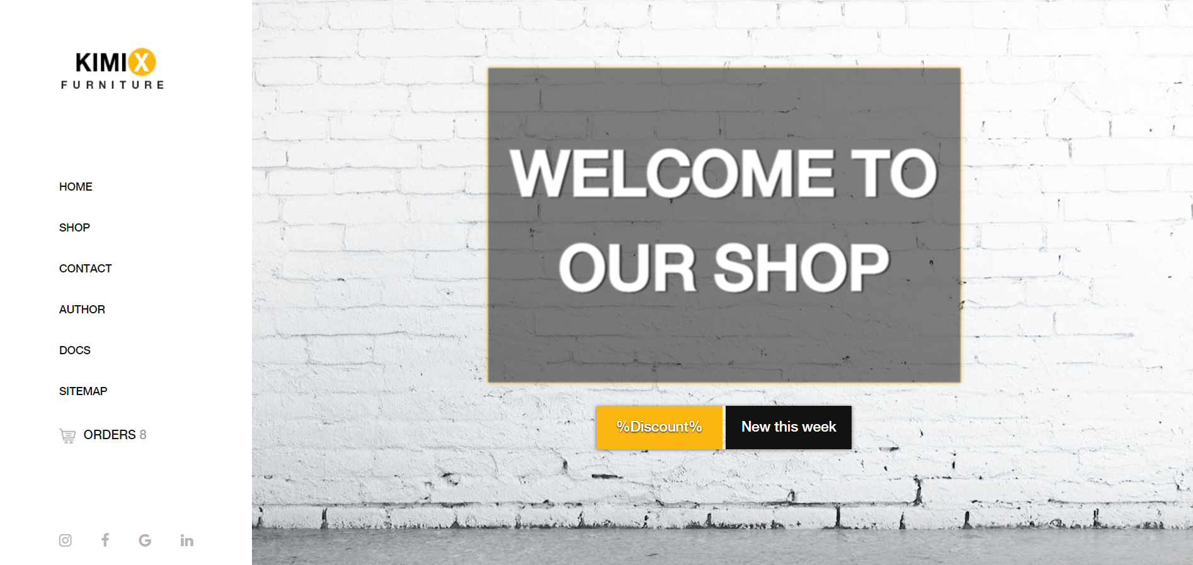

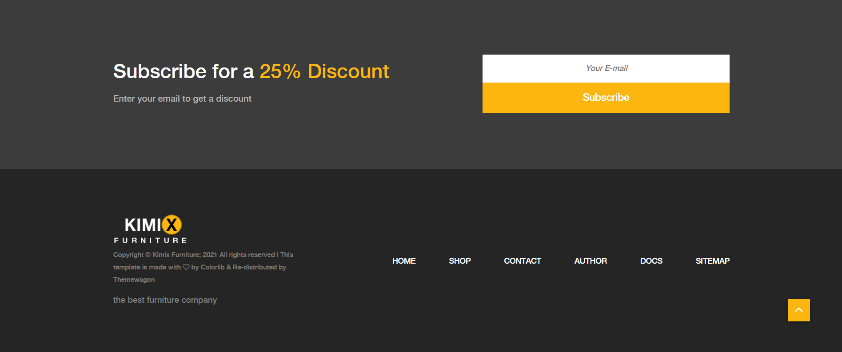

Sve što je obeleženo crvenom bojom je dinamički ispisano.

Takođe na ovoj stranici je iskorišćena funkcija type koja ispisuje tekst “WELCOME TO OUR SHOP”

### Shop.html

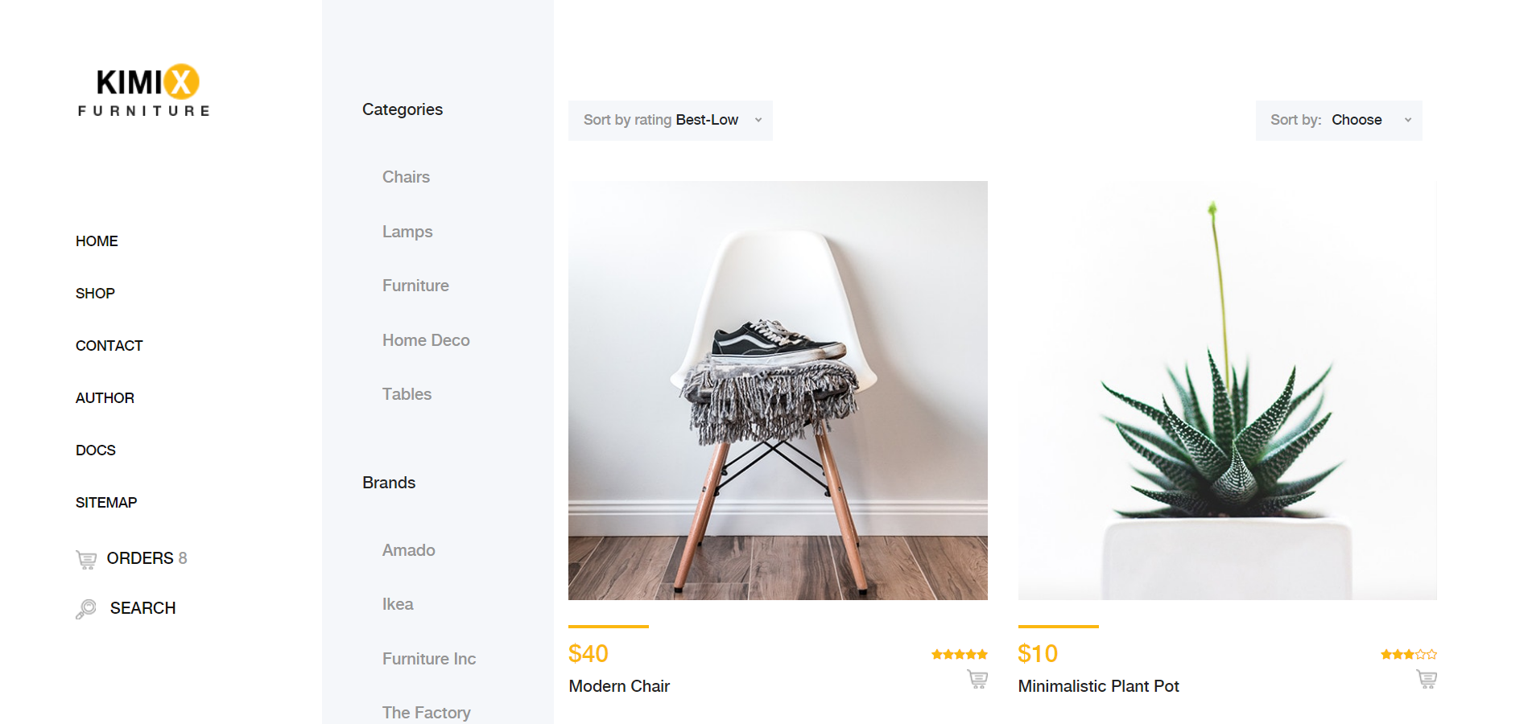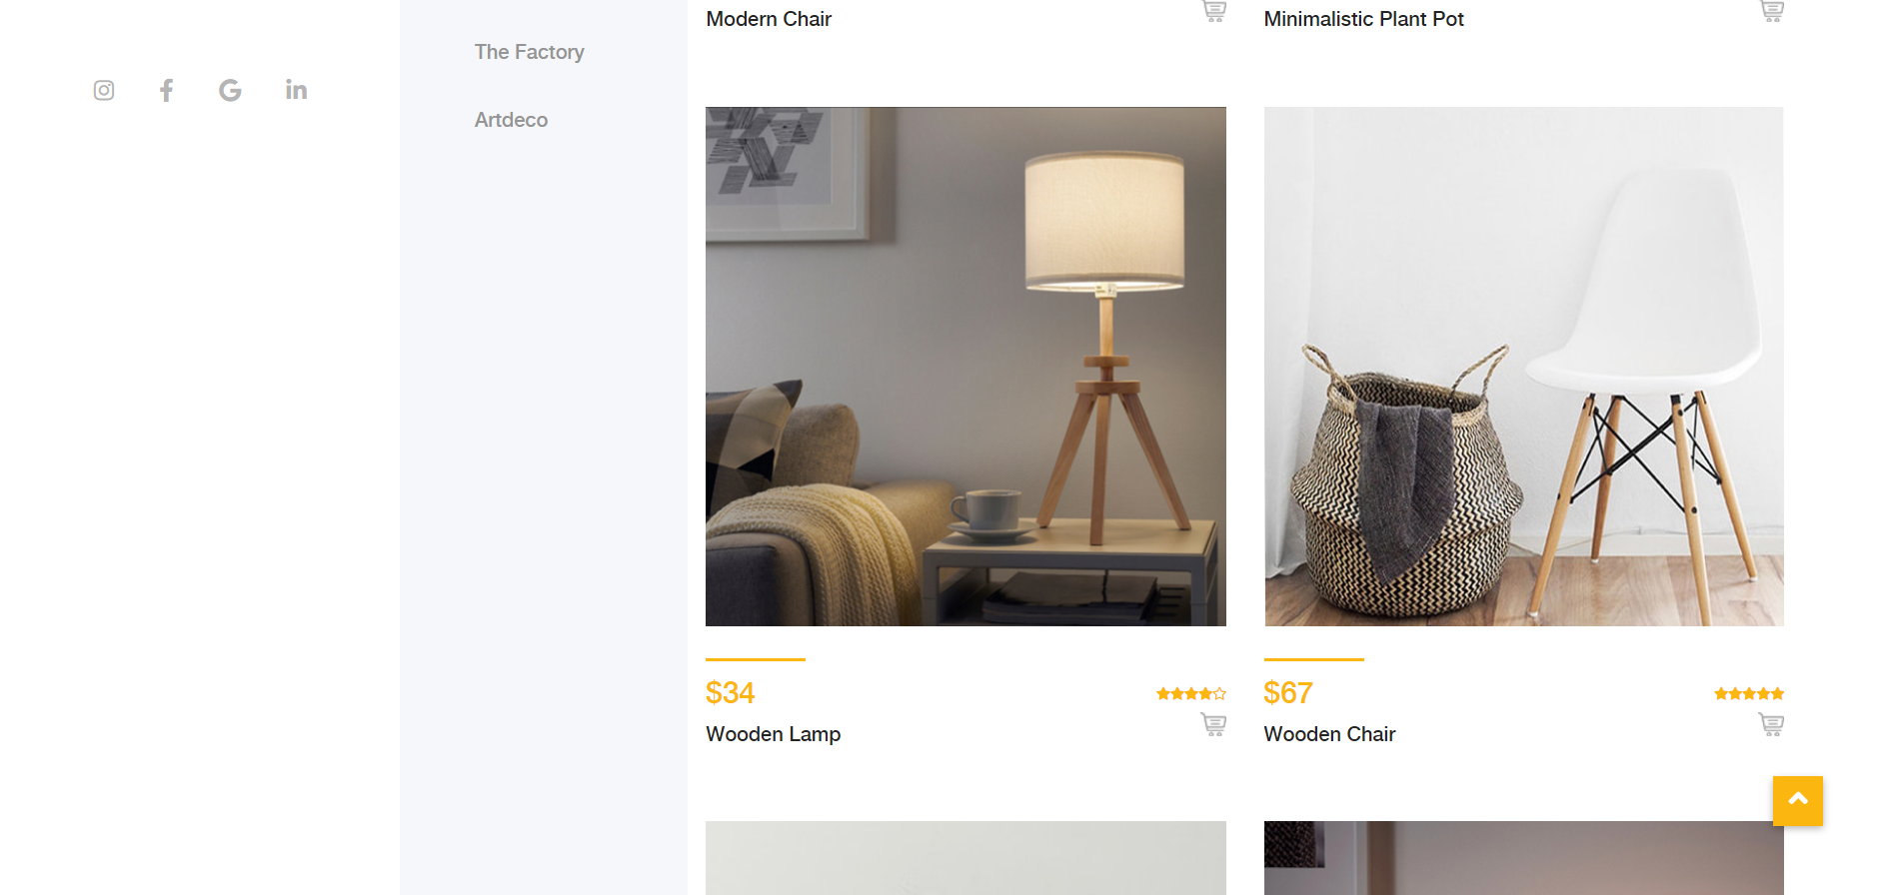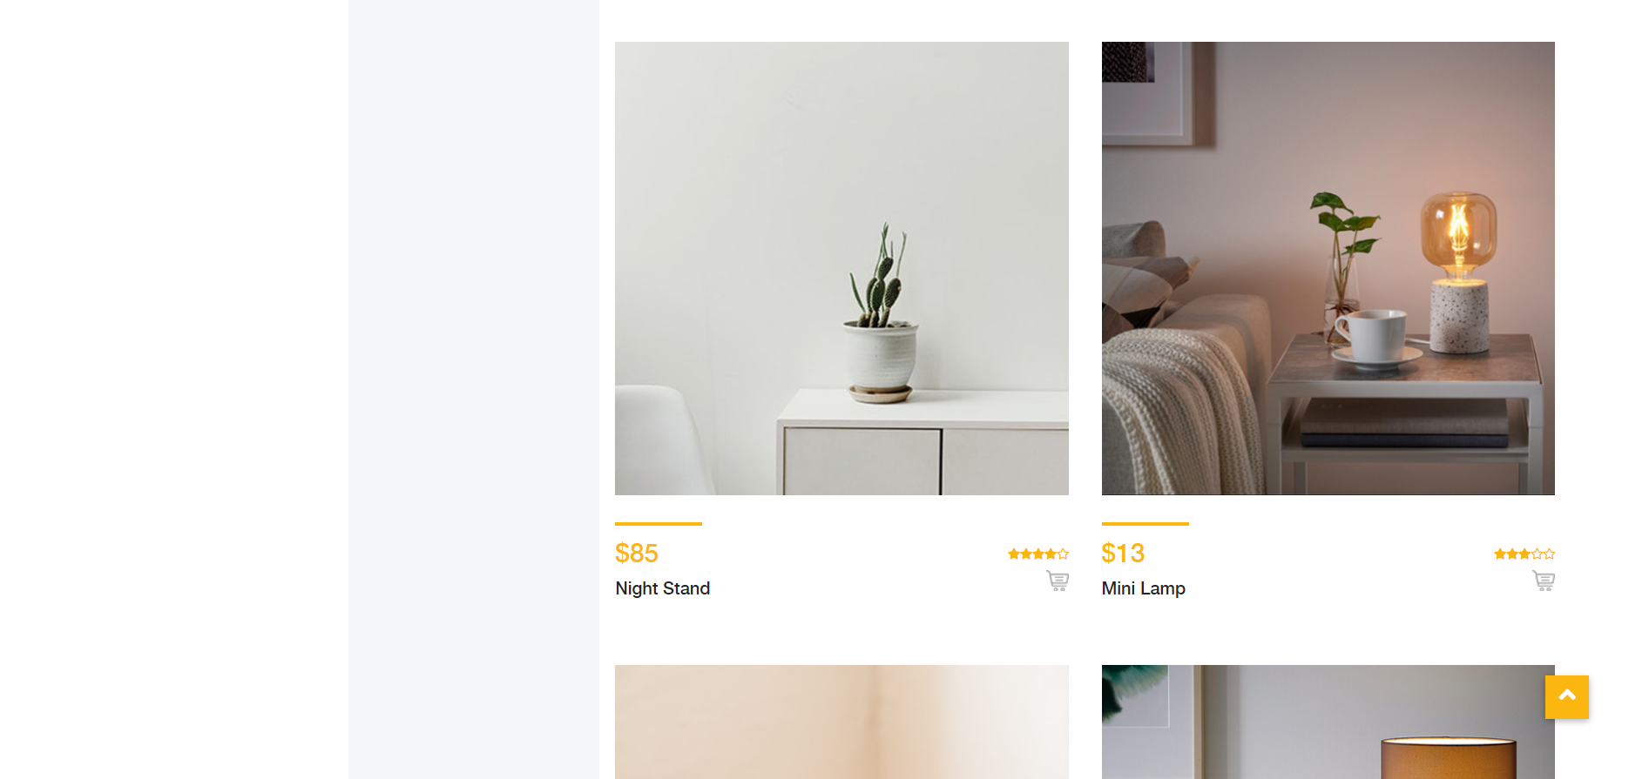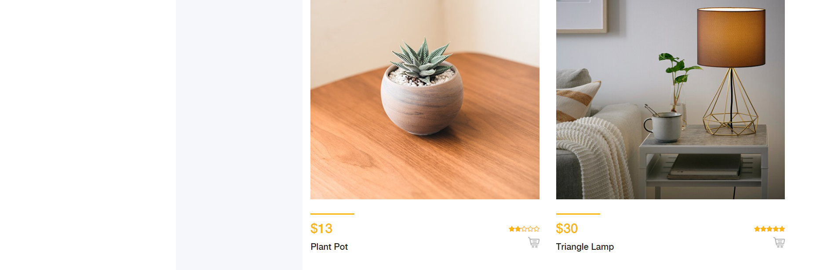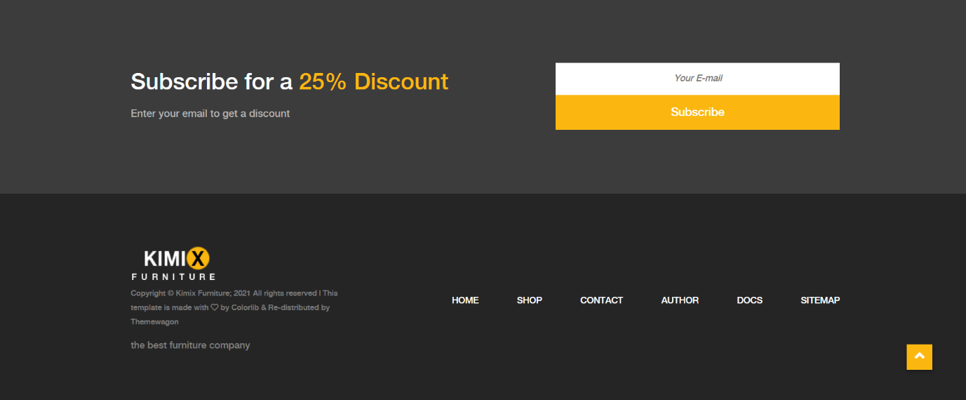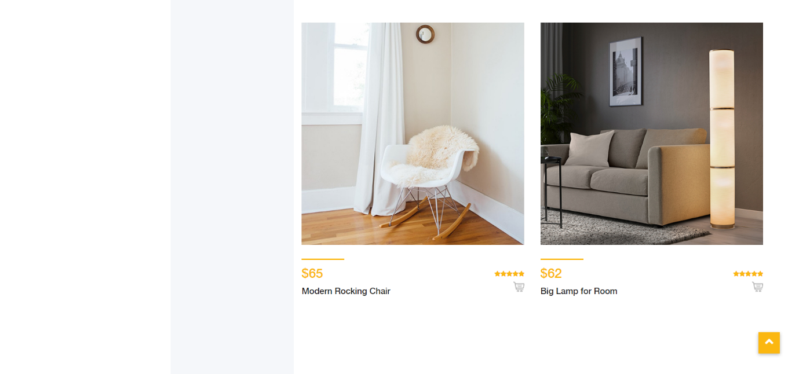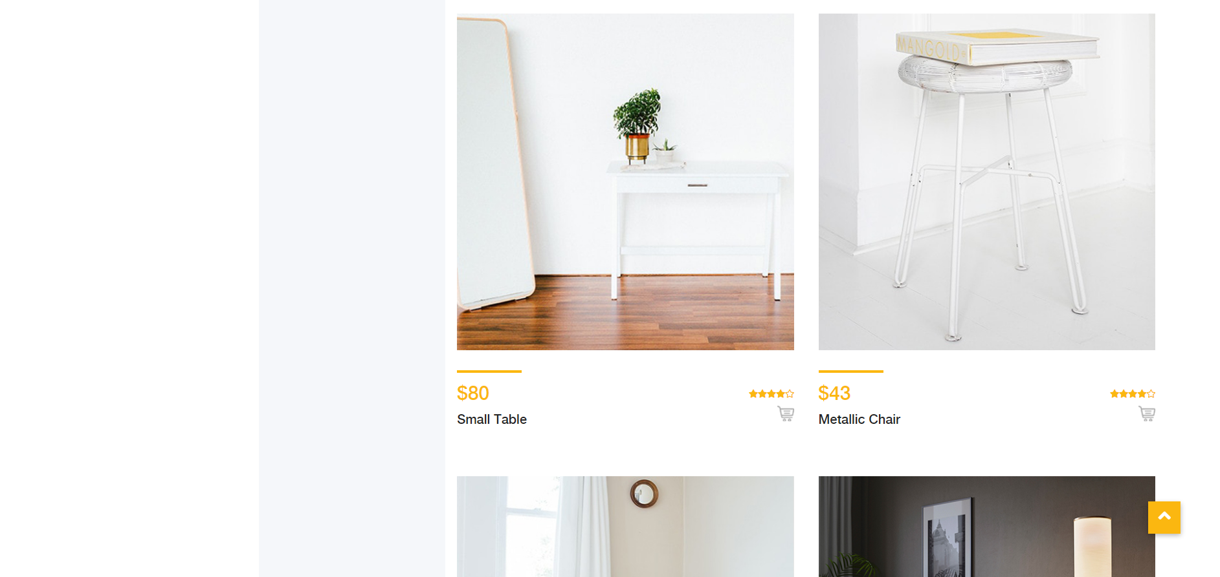

Sve što je uokvireno crvenom bojom je dinamički ispisano (svi produkti su dinamički ispisani, ali je uokviren samo jedan).

Napomena: U toku pravljenja fotografija, top dugme se slučajno našao svakoj slici. Inicijalno se pojavljuje jednom.



Takođe je odrađena validacija polja **NEWSLETTTER EMAIL I OVO JE ISTO NA SVIM STRANICAMA**

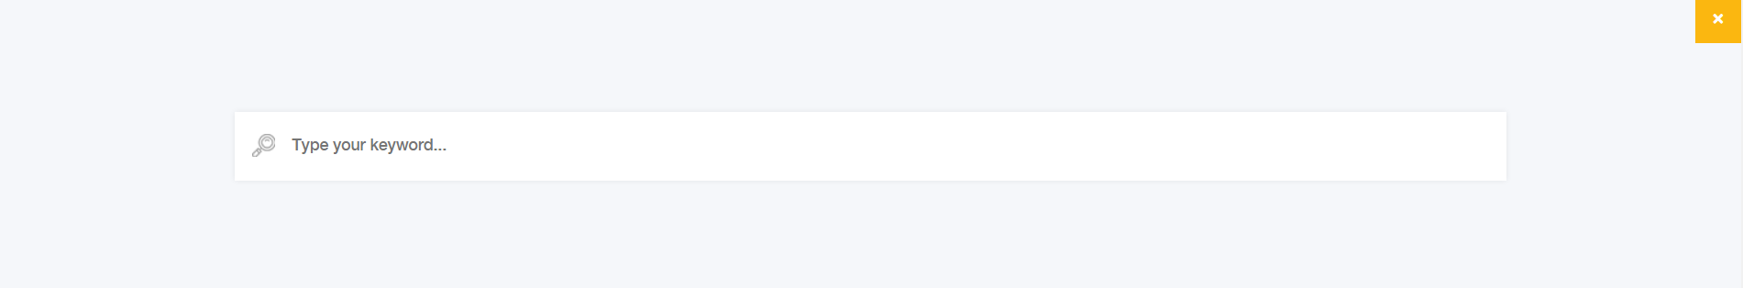

Klikom na polje „search” otvara se polje koje omogućava pretragu proizvoda po nazivu



Polja koja omogućavaju sortiranje proizvoda po oceni, ceni i nazivu.

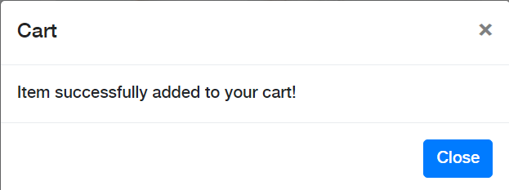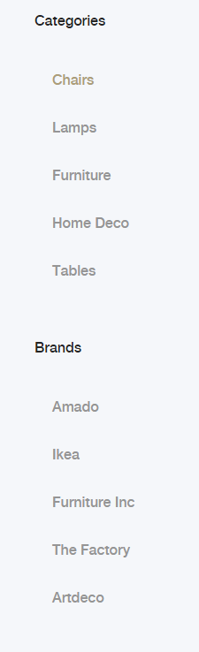

Modal koji se pojavi klikom na dugme add to cart

Klikom na linkove kategorija i brendova vrši se filtriranje proizvoda.



Broj proizvoda koji su dodati u korpu klikom na dugme korpe proizvoda. (LOCAL STORAGE)

### Checkout.html

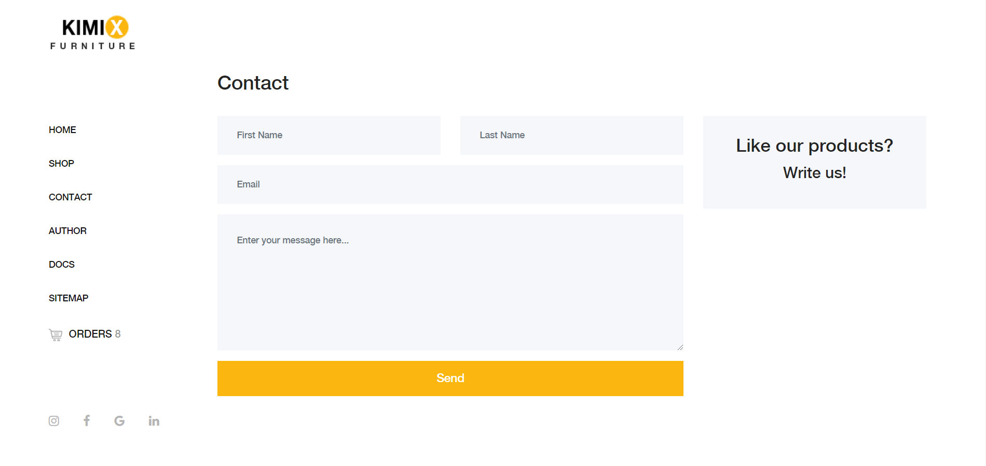

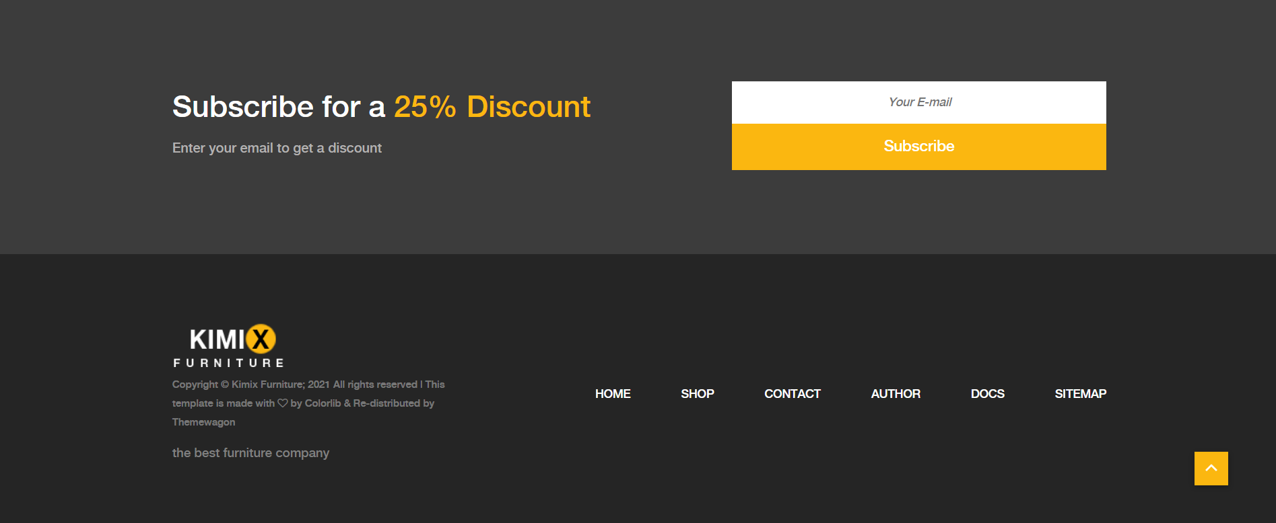

Sve što je uokvireno crvenom bojom je dinamički ispisano.

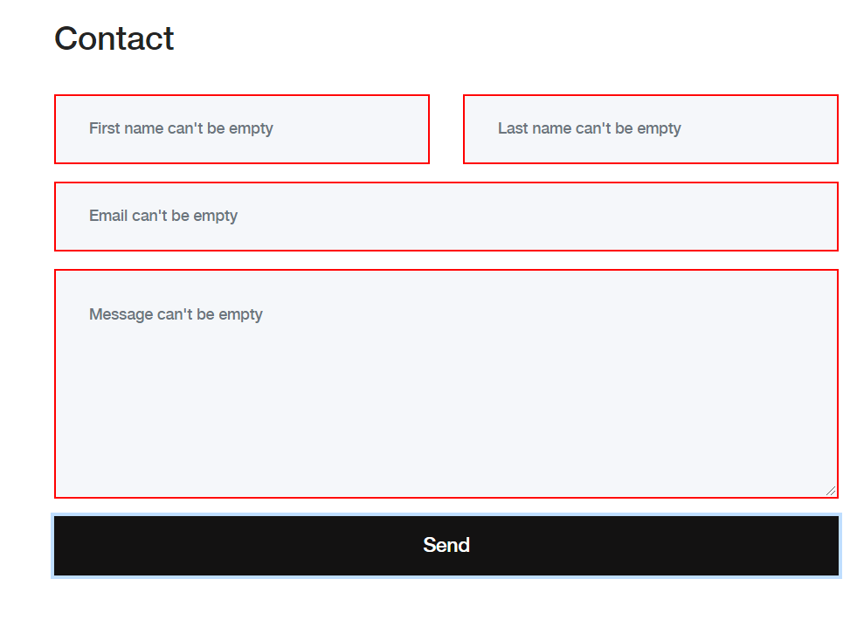 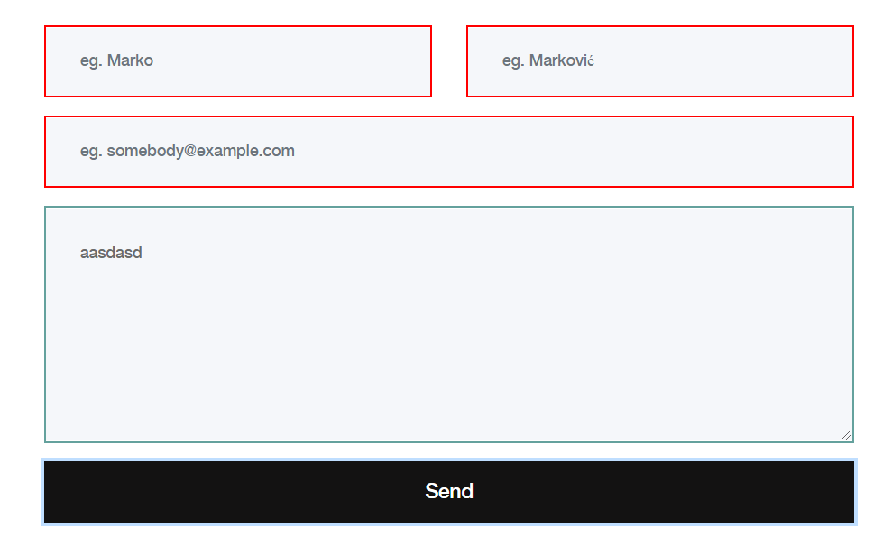

Na ovoj stranici je odrađena kompletna validacija forme. Ako je polje ispravno popunjeno, biće uokvireno zelenom bojom, a ako ne crvenom uz pojavu primera kako bi polje trebalo da bude ispravno popunjeno.

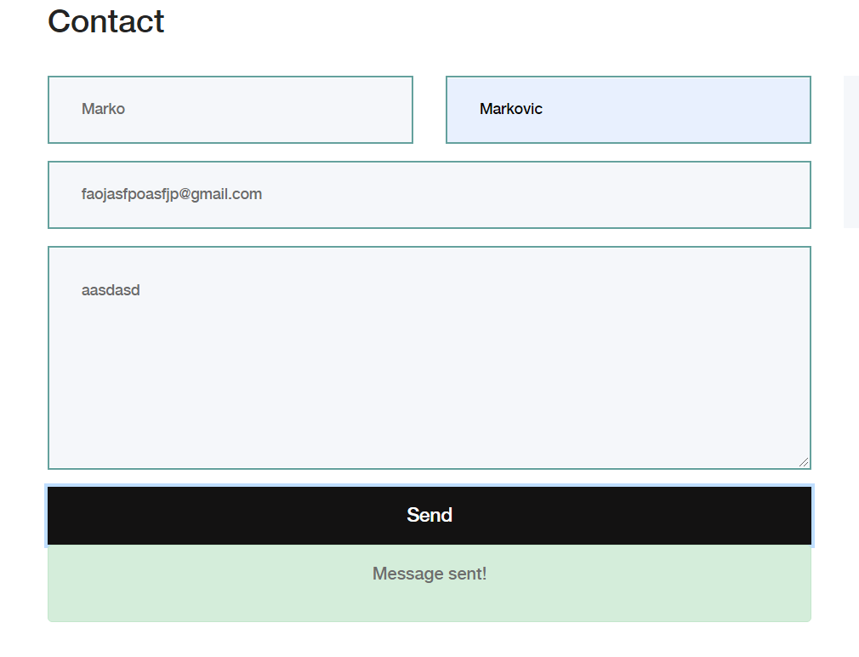

Ako su sva polja ispravno popunjena, pojavljuje se div sa tekstom koje obaveštava korisnika da je forma ispravno popunjena.

### Author.html

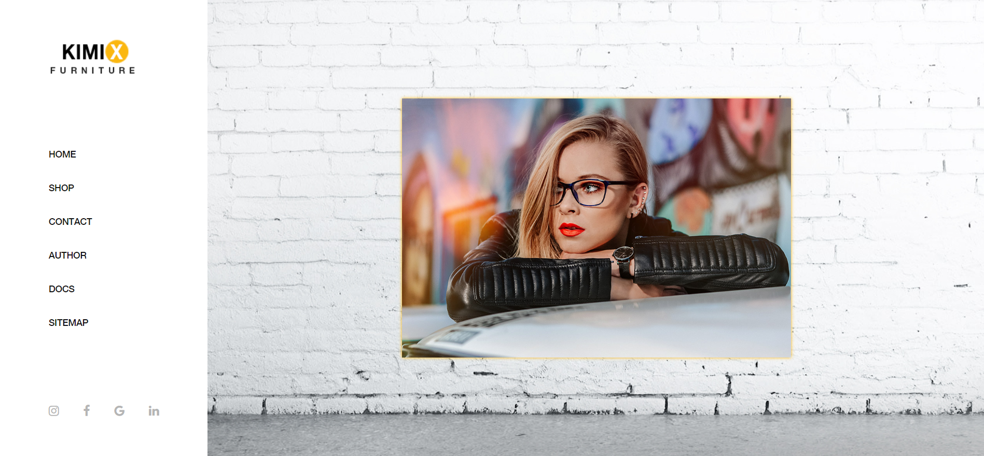



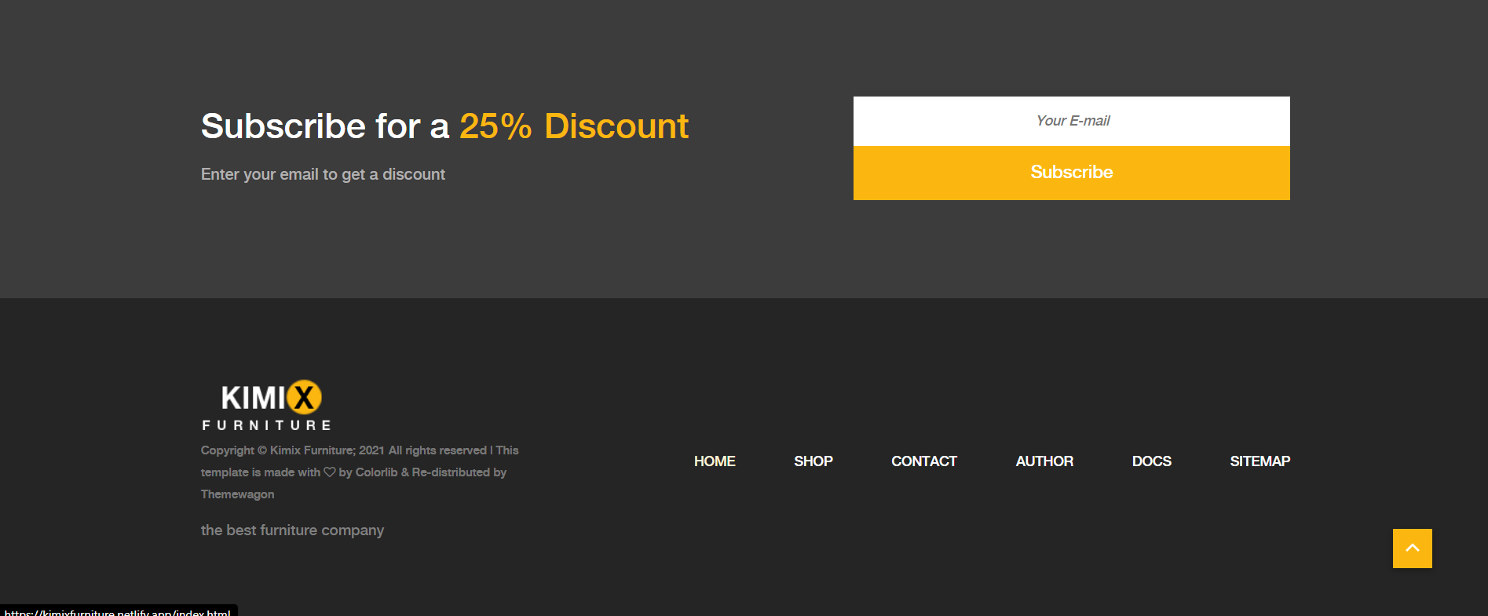

Na ovoj stranici se nalaze sve informacije o autorki i nema nekih posebnih funkcionalnosti, sem validacije newslettera koja je prisutna na svakoj stranici. Svi uokvireni delovi su ispisani dinamički.

## Kodovi

### Index.html

<!DOCTYPE html>

<html lang="en">

<head>

    <meta charset="UTF-8">

    <meta name="description" content="Hello. We are Kimix Furniture! There you can buy the best products from the most famous brands like IKEA!">

    <meta http-equiv="X-UA-Compatible" content="IE=edge">

    <meta name="viewport" content="width=device-width, initial-scale=1, shrink-to-fit=no">

    <!-- The above 4 meta tags *must* come first in the head; any other head content must come *after* these tags -->

    <meta name="keywords" content="furniture,discount,kimix" />

    <meta name="author" content="mailto:kristina.glisovic.55.19@ict.edu.rs" />

    <meta name="copyright" content="Kristina Glišović @ 2021." />

    <!-- Title  -->

    <title>Kimix - Furniture | Home</title>

    <!-- Favicon  -->

    <link rel="icon" href="img/core-img/favicon.ico">

    <!-- Core Style CSS -->

    <link rel="stylesheet" href="css/core-style.css">

    <link rel="stylesheet" href="css/style.min.css">

</head>

<body>

    <!-- ##### Main Content Wrapper Start ##### -->

    <div class="main-content-wrapper d-flex clearfix">

        <!-- Mobile Nav (max width 767px)-->

        <div class="mobile-nav">

            <!-- Navbar Brand -->

            <div class="amado-navbar-brand">

                <a href="index.html"><img src="img/core-img/logo.png" alt="logo"></a>

            </div>

            <!-- Navbar Toggler -->

            <div class="amado-navbar-toggler">

                <span></span><span></span><span></span>

            </div>

        </div>

        <!-- Header Area Start -->

        <header class="header-area clearfix">

                <!-- Close Icon -->

            <div class="nav-close">

                <i class="fa fa-close" aria-hidden="true"></i>

            </div>

            <!-- Logo -->

            <div class="logo">

                <a href="index.html"><img src="img/core-img/logo.png" alt="logo2"></a>

            </div>

            <!-- Amado Nav ISPISAN -->

            <nav class="amado-nav">

            </nav>

            <!-- Cart Menu -->

            <div class="cart-fav-search mb-100">

                <a href="checkout.html" class="cart-nav"><img src="img/core-img/cart.png" alt="cartPng">ORDERS <span>(0)</span></a>

            </div>

            <!-- SOCIAL -->

            <div class="social-info d-flex justify-content-between">

                <!--ispisano-->

            </div>

        </header>

        <!-- Header Area End -->

        <!--SLIDESHOWW-->

        <div class="products-catagories-area clearfix">

            <div id="slideshow">

                <div class="holder">

                    <div class="text" id="text"></div><span class="text"></span>

                </div>

            </div>

            <div class="amado-btn-group mt-30 mb-100 dugme">

                <a href="shop.html" class="btn amado-btn">%Discount%</a>

                <a href="shop.html" class="btn amado-btn active">New this week</a>

            </div>

        </div>

    </div>

    </div>

    <!-- ##### Main Content Wrapper End ##### -->

    <!--NEWSLETTER ISPISANO-->

    <section class="newsletter-area section-padding-100-0">

        <!--ispisano-->

    </section>

    <!-- ##### Newsletter Area End ##### -->

    <!-- ##### Footer Area Start ##### -->

    <footer class="footer_area clearfix">

        <div class="container">

            <div class="row align-items-center">

                <!-- Single Widget Area -->

                <div class="col-12 col-lg-4">

                    <div class="single_widget_area">

                        <!-- Logo -->

                        <div class="footer-logo mr-50">

                            <a href="index.html"><img src="img/core-img/logo2.png" alt="logo"></a>

                        </div>

                        <!-- Copywrite Text -->

                        <p class="copywrite">

                            <!-- Link back to Colorlib can't be removed. Template is licensed under CC BY 3.0. -->

                            Copyright &copy Kimix Furniture;

                            <script>document.write(new Date().getFullYear());</script> All rights reserved | This

                            template is made with <i class="fa fa-heart-o" aria-hidden="true"></i> by <a

                                href="https://colorlib.com" target="_blank">Colorlib</a> & Re-distributed by <a

                                href="https://themewagon.com/" target="_blank">Themewagon</a>

                            <!-- Link back to Colorlib can't be removed. Template is licensed under CC BY 3.0. -->

                        </p>

                        <h1 class="text-dark futerfont">the best furniture company</h1>

                    </div>

                </div>

                <!-- Single Widget Area -->

                <div class="col-12 col-lg-8">

                    <div class="single_widget_area">

                        <!-- Footer Menu -->

                        <div class="footer_menu">

                            <nav class="navbar navbar-expand-lg justify-content-end">

                                <button class="navbar-toggler" type="button" data-toggle="collapse"

                                    data-target="#footerNavContent" aria-controls="footerNavContent"

                                    aria-expanded="false" aria-label="Toggle navigation"><i

                                        class="fa fa-bars"></i></button>

                                <div class="collapse navbar-collapse" id="footerNavContent">

                                    <!--ISPISANO-->

                                </div>

                            </nav>

                        </div>

                    </div>

                </div>

            </div>

        </div>

    </footer>

    <!-- ##### Footer Area End ##### -->

    <!-- ##### jQuery (Necessary for All JavaScript Plugins) ##### -->

    <script src="js/jquery/jquery-2.2.4.min.js"></script>

    <!-- Popper js -->

    <script src="js/popper.min.js"></script>

    <!-- Bootstrap js -->

    <script src="js/bootstrap.min.js"></script>

    <!-- Plugins js -->

    <script src="js/plugins.js"></script>

    <!-- Active js -->

    <script src="js/active.js"></script>

    <!-- Main JS-->

    <script src="js/main.min.js"></script>

</body>

</html>

### Shop.html

<!DOCTYPE html>

<html lang="en">

<head>

    <meta charset="UTF-8">

    <meta name="description" content="There you can see all of our products!">

    <meta http-equiv="X-UA-Compatible" content="IE=edge">

    <meta name="viewport" content="width=device-width, initial-scale=1, shrink-to-fit=no">

    <!-- The above 4 meta tags *must* come first in the head; any other head content must come *after* these tags -->

    <meta name="keywords" content="lamp,furniture,chair" />

    <meta name="author" content="mailto:kristina.glisovic.55.19@ict.edu.rs" />

    <meta name="copyright" content="Kristina Glišović @ 2021." />

    <!-- Title  -->

    <title>Kimix - Furniture | Shop</title>

    <!-- Favicon  -->

    <link rel="icon" href="img/core-img/favicon.ico">

    <!-- Core Style CSS -->

    <link rel="stylesheet" href="css/core-style.css">

    <link rel="stylesheet" href="css/style.min.css">

    <script src="https://kit.fontawesome.com/7bd6858213.js" crossorigin="anonymous"></script>

</head>

<body>

         <!-- Modal -->

     <div class="modal fade" id="staticBackdrop" data-backdrop="static" data-keyboard="false"

         tabindex="-1" aria-labelledby="staticBackdropLabel" aria-hidden="true">

         <div class="modal-dialog">

             <div class="modal-content">

                 <div class="modal-header">

                     <h5 class="modal-title" id="staticBackdropLabel">Cart</h5>

                     <button type="button" class="close" data-dismiss="modal" aria-label="Close">

                         <span aria-hidden="true">&times;</span>

                     </button>

                 </div>

                 <div class="modal-body">

                    Item successfully added to your cart!

                 </div>

                 <div class="modal-footer">

                     <button type="button" class="btn btn-primary" data-dismiss="modal">Close</button>

                 </div>

             </div>

         </div>

     </div>

    <!-- Search Wrapper Area Start -->

    <div class="search-wrapper section-padding-100">

        <div class="search-close">

            <i class="fa fa-close" aria-hidden="true"></i>

        </div>

        <div class="container">

            <div class="row">

                <div class="col-12">

                    <div class="search-content">

                        <form action="#" method="get">

                            <input type="search" name="search" id="search" placeholder="Type your keyword...">

                            <button type="submit"><img src="img/core-img/search.png" alt="search"></button>

                        </form>

                    </div>

                </div>

            </div>

        </div>

    </div>

    <!-- Search Wrapper Area End -->

    <!-- ##### Main Content Wrapper Start ##### -->

    <div class="main-content-wrapper d-flex clearfix">

        <!-- Mobile Nav (max width 767px)-->

        <div class="mobile-nav">

            <!-- Navbar Brand -->

            <div class="amado-navbar-brand">

                <a href="index.html"><img src="img/core-img/logo.png" alt="logo"></a>

            </div>

            <!-- Navbar Toggler -->

            <div class="amado-navbar-toggler">

                <span></span><span></span><span></span>

            </div>

        </div>

        <!-- Header Area Start -->

        <header class="header-area clearfix">

            <!-- Close Icon -->

            <div class="nav-close">

                <i class="fa fa-close" aria-hidden="true"></i>

            </div>

            <!-- Logo -->

            <div class="logo">

                <a href="index.html"><img src="img/core-img/logo.png" alt="logo"></a>

            </div>

            <!-- Amado Nav -->

            <nav class="amado-nav">

                <ul id="navigacija">

                    <!--ISPISANO-->

                </ul>

            </nav>

            <!-- Cart Menu -->

            <div class="cart-fav-search mb-100">

                <a href="checkout.html" class="cart-nav"><img src="img/core-img/cart.png" alt="cartPng">ORDERS <span>(0)</span></a>

                <a href="#" class="search-nav"><img src="img/core-img/search.png" alt="search"> Search</a>

            </div>

            <!-- Social Button -->

            <div class="social-info d-flex justify-content-between">

                <!--ispisano-->

            </div>

        </header>

        <!-- Header Area End -->

        <div class="shop_sidebar_area">

            <!-- ##### Single Widget #####-->

            <div class="widget catagory mb-50">

                <!-- Widget Title -->

                <h6 class="widget-title mb-30">Categories</h6>

                <!--  Catagories ISPISANO  -->

                <div class="catagories-menu">

                    <!--ispisano-->

                </div>

            </div>

            <!-- ##### Single Widget ISPISANO ##### -->

            <div class="widget brands mb-50">

                <!-- Widget Title -->

                <h6 class="widget-title mb-30">Brands</h6>

                <div class="catagories-menu brendoviDrzac">

                    <!--ispisano-->

                </div>

            </div>

            <!-- ##### Single Widget ##### -->

        </div>

        <div class="amado_product_area section-padding-100">

                   <!--ISPISANO-->

                    <!-- Button trigger modal -->

            <div class="container-fluid">

                <!---ISPISATI-->

                <div class="row">

                    <div class="col-12">

                        <div class="product-topbar d-xl-flex align-items-end justify-content-between">

                            <!-- Total Products -->

                            <!-- Sorting -->

                            <div class="product-sorting d-flex">

                                <div class="sort-by-date d-flex align-items-center mr-15">

                                    <p>Sort by rating </p>

                                    <form>

                                        <select name="rate" id="rate" onchange="rating();">

                                            <option value="BL">Best-Low</option>

                                            <option value="LB">Low-Best</option>

                                        </select>

                                    </form>

                                </div>

                            </div>

                            <!-- Sorting -->

                            <div class="product-sorting d-flex">

                                <div class="sort-by-date d-flex align-items-center mr-15">

                                    <p>Sort by: </p>

                                    <form>

                                        <select name="select" id="selected" onchange="sortiranje();">

                                            <option value="izaberi">Choose</option>

                                            <option value="rastuceCena">Price Asc</option>

                                            <option value="opadajuceCena">Price Desc</option>

                                            <option value="rastuceNaziv">A-Z</option>

                                            <option value="opadajuceNaziv">Z-A</option>

                                        </select>

                                    </form>

                                </div>

                            </div>

                        </div>

                    </div>

                </div>

                <div class="row produktiIspis">

                    <!--ispisano-->

                </div>

            </div>

        </div>

    </div>

    <!-- ##### Main Content Wrapper End ##### -->

    <!-- ##### Newsletter Area Start ##### -->

    <section class="newsletter-area section-padding-100-0">

        <div class="container">

            <div class="row align-items-center">

                <!-- Newsletter Text -->

                <div class="col-12 col-lg-6 col-xl-7">

                    <div class="newsletter-text mb-100">

                        <!--ispisano-->

                    </div>

                </div>

                <!-- Newsletter Form -->

                <div class="col-12 col-lg-6 col-xl-5">

                    <div class="newsletter-form mb-100">

                        <form action="#" method="post">

                            <input type="email" name="email" class="nl-email" placeholder="Your E-mail">

                            <input type="submit" value="Subscribe">

                        </form>

                    </div>

                </div>

            </div>

        </div>

    </section>

    <!-- ##### Newsletter Area End ##### -->

    <!-- ##### Footer Area Start ##### -->

    <footer class="footer_area clearfix">

        <div class="container">

            <div class="row align-items-center">

                <!-- Single Widget Area -->

                <div class="col-12 col-lg-4">

                    <div class="single_widget_area">

                        <!-- Logo -->

                        <div class="footer-logo mr-50">

                            <a href="index.html"><img src="img/core-img/logo2.png" alt="logo2"></a>

                        </div>

                        <!-- Copywrite Text -->

                        <p class="copywrite">

                            <!-- Link back to Colorlib can't be removed. Template is licensed under CC BY 3.0. -->

                            Copyright &copy Kimix Furniture;

                            <script>document.write(new Date().getFullYear());</script> All rights reserved | This

                            template is made with <i class="fa fa-heart-o" aria-hidden="true"></i> by <a

                                href="https://colorlib.com" target="_blank">Colorlib</a> & Re-distributed by <a

                                href="https://themewagon.com/" target="_blank">Themewagon</a>

                            <!-- Link back to Colorlib can't be removed. Template is licensed under CC BY 3.0. -->

                        </p>

                        <h1 class="text-dark futerfont">the best furniture company</h1>

                    </div>

                </div>

                <!-- Single Widget Area -->

                <div class="col-12 col-lg-8">

                    <div class="single_widget_area">

                        <!-- Footer Menu -->

                        <div class="footer_menu">

                            <nav class="navbar navbar-expand-lg justify-content-end">

                                <button class="navbar-toggler" type="button" data-toggle="collapse"

                                    data-target="#footerNavContent" aria-controls="footerNavContent"

                                    aria-expanded="false" aria-label="Toggle navigation"><i

                                        class="fa fa-bars"></i></button>

                                <div class="collapse navbar-collapse" id="footerNavContent">

                                    <!--IPISANO-->

                                </div>

                            </nav>

                        </div>

                    </div>

                </div>

            </div>

        </div>

    </footer>

    <!-- ##### Footer Area End ##### -->

    <!-- ##### jQuery (Necessary for All JavaScript Plugins) ##### -->

    <script src="js/jquery/jquery-2.2.4.min.js"></script>

    <!-- Popper js -->

    <script src="js/popper.min.js"></script>

    <!-- Bootstrap js -->

    <script src="js/bootstrap.min.js"></script>

    <!-- Plugins js -->

    <script src="js/plugins.js"></script>

    <!-- Active js -->

    <script src="js/active.js"></script>

    <!-- Main JS-->

    <script src="js/main.min.js"></script>

</body>

</html>

### Checkout.html

<!DOCTYPE html>

<html lang="en">

<head>

    <meta charset="UTF-8">

    <meta name="description" content="There you can write us about our products!">

    <meta http-equiv="X-UA-Compatible" content="IE=edge">

    <meta name="viewport" content="width=device-width, initial-scale=1, shrink-to-fit=no">

    <!-- The above 4 meta tags *must* come first in the head; any other head content must come *after* these tags -->

    <meta name="keywords" content="contact,products" />

    <meta name="author" content="mailto:kristina.glisovic.55.19@ict.edu.rs" />

    <meta name="copyright" content="Kristina Glišović @ 2021." />

    <!-- Title  -->

    <title>Kimix - Furniture | Contact</title>

    <!-- Favicon  -->

    <link rel="icon" href="img/core-img/favicon.ico">

    <!-- Core Style CSS -->

    <link rel="stylesheet" href="css/core-style.css">

    <link rel="stylesheet" href="css/style.min.css">

</head>

<body>

    <!-- Search Wrapper Area Start -->

    <div class="search-wrapper section-padding-100">

        <div class="search-close">

            <i class="fa fa-close" aria-hidden="true"></i>

        </div>

        <div class="container">

            <div class="row">

                <div class="col-12">

                    <div class="search-content">

                        <form action="#" method="get">

                            <input type="search" name="search" id="search" placeholder="Type your keyword...">

                            <button type="submit"><img src="img/core-img/search.png" alt="search"></button>

                        </form>

                    </div>

                </div>

            </div>

        </div>

    </div>

    <!-- Search Wrapper Area End -->

    <!-- ##### Main Content Wrapper Start ##### -->

    <div class="main-content-wrapper d-flex clearfix">

        <!-- Mobile Nav (max width 767px)-->

        <div class="mobile-nav">

            <!-- Navbar Brand -->

            <div class="amado-navbar-brand">

                <a href="index.html"><img src="img/core-img/logo.png" alt="logo"></a>

            </div>

            <!-- Navbar Toggler -->

            <div class="amado-navbar-toggler">

                <span></span><span></span><span></span>

            </div>

        </div>

        <!-- Header Area Start -->

        <header class="header-area clearfix">

            <!-- Close Icon -->

            <div class="nav-close">

                <i class="fa fa-close" aria-hidden="true"></i>

            </div>

            <!-- Logo -->

            <div class="logo">

                <a href="index.html"><img src="img/core-img/logo.png" alt="logo"></a>

            </div>

            <!-- Amado Nav -->

            <nav class="amado-nav">

                 <!--ispisano-->

            </nav>

            <!-- Cart Menu -->

            <div class="cart-fav-search mb-100">

                <a href="checkout.html" class="cart-nav"><img src="img/core-img/cart.png" alt="cartPng">ORDERS <span>(0)</span></a>

            </div>

            <!-- Social Button -->

            <div class="social-info d-flex justify-content-between">

                <!--ISPISANO-->

            </div>

        </header>

        <!-- Header Area End -->

        <div class="cart-table-area section-padding-100">

            <div class="container-fluid">

                <div class="row">

                    <div class="col-12 col-lg-8">

                        <div class="checkout_details_area mt-50 clearfix">

                            <div class="cart-title">

                                <h2>Contact</h2>

                            </div>

                            <form action="#" method="GET">

                                <div class="row">

                                    <div class="col-md-6 mb-3">

                                        <input type="text" class="form-control" id="first_name" value="" placeholder="First Name" required>

                                    </div>

                                    <div class="col-md-6 mb-3">

                                        <input type="text" class="form-control" id="last_name" value="" placeholder="Last Name" required>

                                    </div>

                                    <div class="col-12 mb-3">

                                        <input type="email" class="form-control" id="email" placeholder="Email" value="" required>

                                    </div>

                                    <div class="col-12 mb-3">

                                        <textarea class="form-control" placeholder='Enter your message here...' id="Msg"

                                        rows="3"></textarea>

                                    </div>

                                    <div class="col-12">

                                       <a><input type="button" name="btnSend" id="btnSend" value="Send" class="btn amado-btn w-100"/></a>

                                    </div>

                                    <div class="col-12">

                                        <div class="alert alert-success text-center" id="success">

                                            <p>Message sent!</p></div>

                                    </div>

                                </div>

                            </form>

                        </div>

                    </div>

                    <div class="col-12 col-lg-4">

                        <div class="cart-summary text-center">

                            <h3>Like our products?</h3>

                            <h4>Write us!</h4>

                        </div>

                        </div>

                    </div>

                </div>

            </div>

        </div>

    </div>

    <!-- ##### Main Content Wrapper End ##### -->

    <!-- ##### Newsletter Area Start ##### -->

    <section class="newsletter-area section-padding-100-0">

        <div class="container">

            <div class="row align-items-center">

                <!-- Newsletter Text -->

                <div class="col-12 col-lg-6 col-xl-7">

                    <div class="newsletter-text mb-100">

                        <!---ispisano-->

                    </div>

                </div>

                <!-- Newsletter Form -->

                <div class="col-12 col-lg-6 col-xl-5">

                    <div class="newsletter-form mb-100">

                        <form action="#" method="post">

                            <input type="email" name="email" class="nl-email" placeholder="Your E-mail">

                            <input type="submit" value="Subscribe">

                        </form>

                    </div>

                </div>

            </div>

        </div>

    </section>

    <!-- ##### Newsletter Area End ##### -->

    <!-- ##### Footer Area Start ##### -->

    <footer class="footer_area clearfix">

        <div class="container">

            <div class="row align-items-center">

                <!-- Single Widget Area -->

                <div class="col-12 col-lg-4">

                    <div class="single_widget_area">

                        <!-- Logo -->

                        <div class="footer-logo mr-50">

                            <a href="index.html"><img src="img/core-img/logo2.png" alt="logo2"></a>

                        </div>

                        <!-- Copywrite Text -->

                        <p class="copywrite">

                            <!-- Link back to Colorlib can't be removed. Template is licensed under CC BY 3.0. -->

                            Copyright &copy Kimix Furniture;

                            <script>document.write(new Date().getFullYear());</script> All rights reserved | This

                            template is made with <i class="fa fa-heart-o" aria-hidden="true"></i> by <a

                                href="https://colorlib.com" target="_blank">Colorlib</a> & Re-distributed by <a

                                href="https://themewagon.com/" target="_blank">Themewagon</a>

                            <!-- Link back to Colorlib can't be removed. Template is licensed under CC BY 3.0. -->

                        </p>

                        <h1 class="text-dark futerfont">the best furniture company</h1>

                    </div>

                </div>

                <!-- Single Widget Area -->

                <div class="col-12 col-lg-8">

                    <div class="single_widget_area">

                        <!-- Footer Menu -->

                        <div class="footer_menu">

                            <nav class="navbar navbar-expand-lg justify-content-end">

                                <button class="navbar-toggler" type="button" data-toggle="collapse" data-target="#footerNavContent" aria-controls="footerNavContent" aria-expanded="false" aria-label="Toggle navigation"><i class="fa fa-bars"></i></button>

                                <div class="collapse navbar-collapse" id="footerNavContent">

                                    <!--ISPISANO-->

                                </div>

                            </nav>

                        </div>

                    </div>

                </div>

            </div>

        </div>

    </footer>

    <!-- ##### Footer Area End ##### -->

    <!-- ##### jQuery (Necessary for All JavaScript Plugins) ##### -->

    <script src="js/jquery/jquery-2.2.4.min.js"></script>

    <!-- Popper js -->

    <script src="js/popper.min.js"></script>

    <!-- Bootstrap js -->

    <script src="js/bootstrap.min.js"></script>

    <!-- Plugins js -->

    <script src="js/plugins.js"></script>

    <!-- Active js -->

    <script src="js/active.js"></script>

     <!-- Main JS-->

     <script src="js/main.min.js"></script>

</body>

</html>

### Autor.html

<!DOCTYPE html>

<html lang="en">

<head>

    <meta charset="UTF-8">

    <meta name="description" content="Hello! Im Kristina Glisovic and Im the author of this site">

    <meta http-equiv="X-UA-Compatible" content="IE=edge">

    <meta name="viewport" content="width=device-width, initial-scale=1, shrink-to-fit=no">

    <!-- The above 4 meta tags *must* come first in the head; any other head content must come *after* these tags -->

    <meta name="keywords" content="Kristina, author" />

    <meta name="author" content="mailto:kristina.glisovic.55.19@ict.edu.rs" />

    <meta name="copyright" content="Kristina Glišović @ 2021." />

    <!-- Title  -->

    <title>Kimix - Furniture | Author</title>

    <!-- Favicon  -->

    <link rel="icon" href="img/core-img/favicon.ico">

    <!-- Core Style CSS -->

    <link rel="stylesheet" href="css/core-style.css">

    <link rel="stylesheet" href="css/style.min.css">

</head>

<body>

    <!-- ##### Main Content Wrapper Start ##### -->

    <div class="main-content-wrapper d-flex clearfix">

        <!-- Mobile Nav (max width 767px)-->

        <div class="mobile-nav">

            <!-- Navbar Brand -->

            <div class="amado-navbar-brand">

                <a href="index.html"><img src="img/core-img/logo.png" alt="logo"></a>

            </div>

            <!-- Navbar Toggler -->

            <div class="amado-navbar-toggler">

                <span></span><span></span><span></span>

            </div>

        </div>

        <!-- Header Area Start -->

        <header class="header-area clearfix">

            <!-- Close Icon -->

            <div class="nav-close">

                <i class="fa fa-close" aria-hidden="true"></i>

            </div>

            <!-- Logo -->

            <div class="logo">

                <a href="index.html"><img src="img/core-img/logo.png" alt="logo2"></a>

            </div>

            <!-- Amado Nav ISPISAN -->

            <nav class="amado-nav">

                <!--ispisano-->

            </nav>

            <!-- Cart Menu -->

            <!-- SOCIAL -->

            <div class="social-info mt-100 d-flex justify-content-between">

            </div>

        </header>

        <!-- Header Area End -->

        <!--SLIDESHOWW-->

        <div class="products-catagories-area clearfix">

            <div id="slideshow2">

                <div class="holder">

                    <img src="img/bg-img/foto.jpg" alt="author" />

                </div>

            </div>

        </div>

        <div class="oautoru w-100 text-center">

            <p class="tekstbelo">My name is Kristina and I'm a creator of this site. </p>

            <p class="tekstbelo">I'm currently a student at ICT College, where I've started to learn all about IT, and I'm trying my best to

                improve all of my skills everyday.</p>

        </div>

    </div>

    </div>

    <!-- ##### Main Content Wrapper End ##### -->

     <!--NEWSLETTER ISPISANO-->

    <section class="newsletter-area section-padding-100-0">

        <!--ipisano-->

    </section>

    <!-- ##### Newsletter Area End ##### -->

    <!-- ##### Footer Area Start ##### -->

    <footer class="footer_area clearfix">

        <div class="container">

            <div class="row align-items-center">

                <!-- Single Widget Area -->

                <div class="col-12 col-lg-4">

                    <div class="single_widget_area">

                        <!-- Logo -->

                        <div class="footer-logo mr-50">

                            <a href="index.html"><img src="img/core-img/logo2.png" alt="logo"></a>

                        </div>

                        <!-- Copywrite Text -->

                        <p class="copywrite">

                            <!-- Link back to Colorlib can't be removed. Template is licensed under CC BY 3.0. -->

                            Copyright &copy Kimix Furniture;

                            <script>document.write(new Date().getFullYear());</script> All rights reserved | This

                            template is made with <i class="fa fa-heart-o" aria-hidden="true"></i> by <a

                                href="https://colorlib.com" target="_blank">Colorlib</a> & Re-distributed by <a

                                href="https://themewagon.com/" target="_blank">Themewagon</a>

                            <!-- Link back to Colorlib can't be removed. Template is licensed under CC BY 3.0. -->

                        </p>

                        <h1 class="text-dark futerfont">the best furniture company</h1>

                    </div>

                </div>

                <!-- Single Widget Area -->

                <div class="col-12 col-lg-8">

                    <div class="single_widget_area">

                        <!-- Footer Menu -->

                        <div class="footer_menu">

                            <nav class="navbar navbar-expand-lg justify-content-end">

                                <button class="navbar-toggler" type="button" data-toggle="collapse"

                                    data-target="#footerNavContent" aria-controls="footerNavContent"

                                    aria-expanded="false" aria-label="Toggle navigation"><i

                                        class="fa fa-bars"></i></button>

                                <div class="collapse navbar-collapse" id="footerNavContent">

                                    <!--ISPISANO-->

                                </div>

                            </nav>

                        </div>

                    </div>

                </div>

            </div>

        </div>

    </footer>

    <!-- ##### Footer Area End ##### -->

    <!-- ##### jQuery (Necessary for All JavaScript Plugins) ##### -->

    <script src="js/jquery/jquery-2.2.4.min.js"></script>

    <!-- Popper js -->

    <script src="js/popper.min.js"></script>

    <!-- Bootstrap js -->

    <script src="js/bootstrap.min.js"></script>

    <!-- Plugins js -->

    <script src="js/plugins.js"></script>

    <!-- Active js -->

    <script src="js/active.js"></script>

    <!-- Main JS-->

    <script src="js/main.min.js"></script>

</body>

</html>

### Brands.json

[

    {

        "brandId":1,

        "name":"Amado"

    },

    {

        "brandId":2,

        "name":"Ikea"

    },

    {

        "brandId":3,

        "name":"Furniture Inc"

    },

    {

        "brandId":4,

        "name":"The factory"

    },

    {

        "brandId":5,

        "name":"Artdeco"

    }

]

### Categories.json

[

    {

        "categId":1,

        "name":"Chairs"

    },

    {

        "categId":2,

        "name":"Lamps"

    },

    {

        "categId":3,

        "name":"Furniture"

    },

    {

        "categId":4,

        "name":"Home Deco"

    },

    {

        "categId":5,

        "name":"Tables"

    }

]

### Menu.json

[

    {

    "naziv": "HOME",

    "putanja": "index.html"

    },

    {

    "naziv": "SHOP",

    "putanja": "shop.html"

    },

    {

    "naziv": "CONTACT",

    "putanja": "checkout.html"

    },

    {

    "naziv": "AUTHOR",

    "putanja": "autor.html"

    },

    {

    "naziv": "DOCS",

    "putanja": "docs.pdf"

    },

    {

    "naziv": "SITEMAP",

    "putanja": "sitemap.xml"

    }

]

### Proizvodi.json

[

    {

        "slika":{

            "putanjaSlike":"img/bg-img/1.jpg",

            "alt":"chair"

        },

        "cena":40,

        "naslov":"Modern Chair",

        "tag":"modernchair",

        "brojZvezdica":5,

        "categId":1,

        "brandId":2,

        "incart":0

    },

    {

        "slika":{

            "putanjaSlike":"img/bg-img/2.jpg",

            "alt":"minipot"

        },

        "cena":10,

        "naslov":"Minimalistic Plant Pot",

        "tag":"miniplant",

        "brojZvezdica":3,

        "categId":4,

        "brandId":5,

        "incart":0

    },

    {

        "slika":{

            "putanjaSlike":"img/bg-img/9.jpg",

            "alt":"lamp"

        },

        "cena":34,

        "naslov":"Wooden Lamp",

        "tag":"woodlamp",

        "brojZvezdica":4,

        "categId":2,

        "brandId":3,

        "incart":0

    },

    {

            "slika":{

            "putanjaSlike":"img/bg-img/3.jpg",

            "alt":"woodenchair"

        },

        "cena":67,

        "naslov":"Wooden Chair",

        "tag":"woodenchair",

        "brojZvezdica":5,

        "categId":1,

        "brandId":3,

        "incart":0

    },

    {

        "slika":{

            "putanjaSlike":"img/bg-img/4.jpg",

            "alt":"nightstand"

        },

        "cena":85,

        "naslov":"Night Stand",

        "tag":"nightstand",

        "brojZvezdica":4,

        "categId":5,

        "brandId":1,

        "incart":0

    },

    {

        "slika":{

            "putanjaSlike":"img/bg-img/12.jpg",

            "alt":"minilamp"

        },

        "cena":13,

        "naslov":"Mini Lamp",

        "tag":"minilamp",

        "brojZvezdica":3,

        "categId":2,

        "brandId":3,

        "incart":0

    },

    {

        "slika":{

            "putanjaSlike":"img/bg-img/5.jpg",

            "alt":"plantPot"

        },

        "cena":13,

        "naslov":"Plant Pot",

        "tag":"plantpot",

        "brojZvezdica":2,

        "categId":4,

        "brandId":4,

        "incart":0

    },

    {

        "slika":{

            "putanjaSlike":"img/bg-img/10.jpg",

            "alt":"orangelamp"

        },

        "cena":30,

        "naslov":"Triangle Lamp",

        "tag":"trianglelamp",

        "brojZvezdica":5,

        "categId":2,

        "brandId":5,

        "incart":0

    },

    {

        "slika":{

            "putanjaSlike":"img/bg-img/6.jpg",

            "alt":"table"

        },

        "cena":80,

        "naslov":"Small Table",

        "tag":"smalltable",

        "brojZvezdica":4,

        "categId":5,

        "brandId":2,

        "incart":0

    },

    {

        "slika":{

            "putanjaSlike":"img/bg-img/7.jpg",

            "alt":"chair"

        },

        "cena":43,

        "naslov":"Metallic Chair",

        "tag":"metalchair",

        "brojZvezdica":4,

        "categId":1,

        "brandId":3,

        "incart":0

    },

    {

        "slika":{

            "putanjaSlike":"img/bg-img/8.jpg",

            "alt":"rockingchair"

        },

        "cena":65,

        "naslov":"Modern Rocking Chair",

        "tag":"rockchair",

        "brojZvezdica":5,

        "categId":3,

        "brandId":4,

        "incart":0

    },

    {

        "slika":{

            "putanjaSlike":"img/bg-img/11.jpg",

            "alt":"biglamp"

        },

        "cena":62,

        "naslov":"Big Lamp for Room",

        "tag":"biglamp",

        "brojZvezdica":5,

        "categId":2,

        "brandId":1,

        "incart":0

    }

]

### Style.css

* {

  margin: 0;

  padding: 0;

  box-sizing: border-box;

  list-style: none;

}

/*index*/

.products-catagories-area {

  background-image: url(../img/prodPoz.jpg);

  background-repeat: no-repeat;

  background-size: cover;

  justify-content: center;

  flex-direction: column;

  display: flex;

  align-items: center;

}

#slideshow {

  background-color: rgba(0, 0, 0, 0.5);

  width: 600px;

  height: 400px;

  box-shadow: 0px 0px 5px #fbb710;

  filter: blur(1px);

  overflow: hidden;

}

#slideshow2 {

  background-color: rgba(0, 0, 0, 0.5);

  width: 600px;

  height: 400px;

  box-shadow: 0px 0px 5px #fbb710;

  overflow: hidden;

}

.holder {

  height: 100%;

  width: 100%;

  display: flex;

  justify-content: center;

  align-items: center;

  text-align: center;

}

.text {

  font-weight: 800;

  font-size: 5rem;

  text-transform: uppercase;

  color: white;

  text-shadow: 2px 1px 2px black;

}

.tekstbelo {

  color: white !important;

  margin: 10px;

}

.oautoru {

  background-color: black;

  padding: 50px 0px;

}

span {

  margin-bottom: 10px;

}

.dugme {

  box-shadow: 0px 1px 5px #666;

}

.dugme a {

  text-shadow: 0px 1px 2px black;

}

.cart-nav {

  padding-top: 20px !important;

}

.futerfont{

  font-size: 15px;

  color: gray !important;

}

/*responsive*/

@media (max-width: 900px) {

  #slideshow, #slideshow2 {

    width: 470px;

  }

  .text {

    font-size: 4rem;

  }

}

@media (max-width: 766px) {

  .products-catagories-area {

    height: 100vh;

  }

  #slideshow, #slideshow2 {

    width: 80%;

  }

}

@media (max-width: 500px) {

  #slideshow, #slideshow2 {

    width: 87%;

  }

  .text {

    font-size: 3rem;

  }

  .amado-btn {

    min-width: 130px !important;

  }

}

### Main.js

var url = window.location.href;

//sve f-je

//globalnefunkcije

const baseurl = "data/";

//ajax callback

function ajaxCallBack(url, method, result) {

    $.ajax({

        url: url,

        method: method,

        dataType: "json",

        success: result,

        error: function (xhr) { console.log(xhr); }

    });

}

//LOCAL STORAGE

function upisiLS(name, data){

localStorage.setItem(name, JSON.stringify(data));

}

function dohvatiLS(name){

return JSON.parse(localStorage.getItem(name));

}

//sort by rate

function rating() {

    var izabrano = document.querySelector("#rate").value;

    var productForSortbyRate = dohvatiLS('productsLocal');

    if (izabrano == 'LB') {

        productForSortbyRate = productForSortbyRate.sort(function (a, b) {

            return a.brojZvezdica - b.brojZvezdica;

        })

    }

    else if (izabrano == 'BL') {

        productForSortbyRate = productForSortbyRate.sort(function (a, b) {

            return b.brojZvezdica - a.brojZvezdica;

        })

    }

    productIspis(productForSortbyRate);

}

//sort by values

function sortiranje() {

    var izabrano = document.querySelector("#selected").value;

    var productForSort = dohvatiLS('productsLocal');

    //console.log(idproizovda)

    if (izabrano == 'izaberi') {

        ajaxCallBack(baseurl + "proizvodi.json", "GET", function (result) {

            //console.log(result);

            productIspis(result);

        });

    }

    else if (izabrano == 'rastuceCena') {

        productForSort = productForSort.sort(function (a, b) {

            return a.cena - b.cena;

        })

    }

    else if (izabrano == 'opadajuceCena') {

        productForSort = productForSort.sort(function (a, b) {

            return b.cena - a.cena;

        })

    }

    else if (izabrano == 'rastuceNaziv') {

        productForSort = productForSort.sort(function (a, b) {

            if (a.naslov > b.naslov) {

                return 1;

            }

            else if (a.naslov < b.naslov) {

                return -1;

            }

            return 0;

        })

    }

    else if (izabrano == 'opadajuceNaziv') {

        productForSort = productForSort.sort(function (a, b) {

            if (a.naslov > b.naslov) {

                return -1;

            }

            else if (a.naslov < b.naslov) {

                return 1;

            }

            return 0;

        })

    }

    productIspis(productForSort);

}

//typing

function typing() {

    let tekst = document.getElementById("text");

    const slova = ["W", "E", "L", "C", "O", "M", "E", " ", "T", "O", " ", "O", "U", "R", " ", "S", "H", "O", "P"];

    //ispis

    setTimeout(

        () =>

            slova.forEach((slova, i) => {

                setTimeout(() => {

                    tekst.innerHTML += slova;

                }, i * 500);

            }),

        //brzina kucanja

        500

    );

}

//social

function ispisSocial() {

    let socWrapper = document.querySelector('.social-info');

    let ispisSoc = '';

    const mreze = ["fa fa-instagram", "fa fa-facebook", "fa fa-google", "fa fa-linkedin"]

    const linkovi = ["www.instagram.com", "www.facebook.com", "https://mail.google.com/mail/?view=cm&fs=1&tf=1&to=kimixphotography@gmail.com", "www.linkedin.com"];

    for (let i = 0; i < mreze.length; i++) {

        ispisSoc += `<a href = "${linkovi[i]}"><i class="${mreze[i]}" aria-hidden="true"></i></a> `;

    }

    socWrapper.innerHTML = ispisSoc;

}

//newsletter

function newsletter() {

    let newsWrapper = document.querySelector('.newsletter-area');

    let ispisNews = `<div class="container">

        <div class="row align-items-center">

            <!-- Newsletter Text -->

            <div class="col-12 col-lg-6 col-xl-7">

                <div class="newsletter-text mb-100">

                <h2>Subscribe for a <span>25% Discount</span></h2>

        <p>Enter your email to get a discount</p>

                </div>

            </div>

            <!-- Newsletter Form -->

            <div class="col-12 col-lg-6 col-xl-5">

                <div class="newsletter-form mb-100">

                    <form>

                        <input type="email" name="email" class="nl-email text-center" placeholder="Your E-mail">

                        <input type="button" class="btn amado-btn w-100" id="newsSend" value="Subscribe">

                    </form>

                </div>

                </div>

            </div>

        </div>

    </div>`;

    newsWrapper.innerHTML = ispisNews;

}

//footernav

function ispisFooterNav(data) {

    let footerNav = document.querySelector('#footerNavContent')

    let ispisFooter = '<ul class="navbar-nav ml-auto">';

    for (let i = 0; i < data.length; i++) {

        ispisFooter += `<li class="nav-item">

                    <a class="nav-link" href="${data[i].putanja}">${data[i].naziv}</a>

               </li>`

    }

    ispisFooter += `</ul>`;

    footerNav.innerHTML = ispisFooter;

}

//ISPIS NAVIGACIJE

function ispisiNavigaciju(data) {

    let navHolder = document.querySelector('.amado-nav');

    let ispis = '<ul>';

    for (let i = 0; i < data.length; i++) {

        ispis += `<li>

        <a href="${data[i].putanja}">${data[i].naziv}</a>

        </li>`;

    }

    ispis += '</ul>';

    navHolder.innerHTML = ispis;

     //debugger;

}

// funckija sa ispisivanje zvezdica

function zvezdice(brojZvezdica) {

    let html = "";

    for (let i = 1; i <= 5; i++) {

        if (i <= brojZvezdica) {

            html += `<i class="fas fa-star"></i>`

        }

        else {

            html += `<i class="far fa-star"></i>`

        }

    }

    return html;

}

//ispisprod

function productIspis(data) {

     //debugger;

    let prodWrapp = document.querySelector('.produktiIspis');

    let ispis = '';

    data.forEach(product => {

        ispis += `<div class="col-12 col-sm-6 col-md-12 col-xl-6 prikaz">

        <div class="single-product-wrapper">

            <!-- Product Image -->

            <div class="product-img">

                <img src="${product.slika.putanjaSlike}" alt="${product.slika.alt}">

            </div>

            <!-- Product Description -->

            <div class="product-description d-flex align-items-center justify-content-between">

                <!-- Product Meta Data -->

                <div class="product-meta-data">

                    <div class="line"></div>

                    <p class="product-price">$${product.cena}</p>

                        <h6>${product.naslov}</h6>

                </div>

                <!-- Ratings & Cart -->

                <div class="ratings-cart text-right">

                    <div class="ratings">

                    ${zvezdice(product.brojZvezdica)}

                    </div>

                    <div class="cart">

                        <a href="" class="add-to-cart" data-toggle="modal" data-target="#staticBackdrop" data-placement="left" title="Add to Cart"><img src="img/core-img/cart.png" alt="cart"></a>

                    </div>

                </div>

            </div>

        </div>

    </div>`;

    });

    prodWrapp.innerHTML = ispis;

    upisiLS('productsLocal',data);

    var productCart = dohvatiLS('productsLocal');

    var carts = document.querySelectorAll('.add-to-cart');

    for (let i = 0; i < carts.length; i++) {

        carts[i].addEventListener('click', () => {

            cartNumbers(productCart[i]);

            totalCost(productCart[i]);

        })

    }

}

//cart

//local storage for cart

function onLoadNumbers() {

    let productNumbers = dohvatiLS('cartNumbers');

    if (productNumbers) {

        document.querySelector('.cart-nav span').textContent = productNumbers;

    }

}

//local storage for cart

function cartNumbers(product) {

    let productNumbers = dohvatiLS('cartNumbers');

    productNumbers = parseInt(productNumbers);

    if (productNumbers) {

        upisiLS('cartNumbers', productNumbers + 1);

        document.querySelector('.cart-nav span').textContent = productNumbers + 1;

    }

    else {

        upisiLS('cartNumbers', 1);

        document.querySelector('.cart-nav span').textContent = 1;

    }

    setItems(product);

}

//local storage for cart

function setItems(product) {

    let cartItems = dohvatiLS('productsInCart');

    //console.log('itemsi su', cartItems);

    //debugger;

    if (cartItems != null) {

        if (cartItems[product.tag] == undefined) {

            cartItems = {

                ...cartItems,

                [product.tag]: product

            }

        }

        cartItems[product.tag].incart += 1;

    }

    else {

        product.incart = 1;

        cartItems = {

            [product.tag]: product

        }

    }

    upisiLS('productsInCart', cartItems);

}

//totalnacena

function totalCost(product) {

    // console.log("cena je",product.cena);

    let cartCost = dohvatiLS("totalCost");

    //console.log("my cart cost is",cartCost);

    if (cartCost != null) {

        cartCost = parseInt(cartCost);

        upisiLS("totalCost", cartCost + product.cena);

    }

    else {

        upisiLS("totalCost", product.cena);

    }

}

//search

function pretraga() {

    var uneto = this.value.toLowerCase();

    ajaxCallBack(baseurl + "proizvodi.json", "GET", function (result) {

        const pretrazeno = result.filter(function (p) {

            if (p.naslov.toLowerCase().indexOf(uneto) != -1) {

                return true;

            }

        })

        productIspis(pretrazeno);

    })

}

//kateg

function ispisKategorija(data) {

    let ispis = "<ul>";

    data.forEach(element => {

        ispis += `<li><a href="#" class="cat" data-idkat="${element.categId}">${element.name}</a></li>`;

    });

    ispis += "</ul>";

    document.querySelector('.catagories-menu').innerHTML = ispis;

    $(".catagories-menu ul li a").click(filtrirajProizvodePoKategoriji);

}

//po kategoriji

function filtrirajProizvodePoKategoriji(e) {

    e.preventDefault();

    const idKat = this.dataset.idkat;

    ajaxCallBack(baseurl + "proizvodi.json", "GET", function (result) {

        //console.log(result);

        // const filtriraniPostovi = postovi.filter(function (el) {

        //   return el.(function (kat) {

        //     return kat.categId == idKat

        //   });

        const filtriraniProizvodi = result.filter(function (c) {

            if (c.categId == idKat) {

                return c;

            }

        });

        productIspis(filtriraniProizvodi);

    });

}

function brands(data) {

    let brandsWrapp = document.querySelector('.brendoviDrzac');

    let ispis = '<ul>';

    data.forEach(element => {

        ispis += `<li><a href="#" class="brendovi" data-idkat="${element.brandId}">${element.name}</a></li>`;

    });

    ispis += '</ul>';

    brandsWrapp.innerHTML = ispis;

    $(".brendovi").click(filterPoBrendu);

}

//filter po brendu

function filterPoBrendu(e) {

    e.preventDefault();

    const idBrend = this.dataset.idkat;

    ajaxCallBack(baseurl + "proizvodi.json", "GET", function (result) {

        const filtriraniPostovi = result.filter(function (b) {

            if (b.categId == idBrend) {

                return b;

            }

        });

        productIspis(filtriraniPostovi);

    });

}

//validacija

function validate() {

    //panel koji iskace ako je forma dobra

    var successPanel = $("#success");

    successPanel.hide();

    //elements

    let formData = [];

    let btnSend = $('#btnSend');

    btnSend.click(function () {

        let firstName = $('#first_name');

        let lastName = $("#last_name");

        let email = $("#email");

        let message = $("#Msg");

        //regex

        let regIme = /^[A-ZČĆŠĐŽ][a-zčćšđž]{2,18}$/;

        let regPrezime = /^[A-ZČĆŠĐŽ][a-zčćšđž]{2,20}$/;

        let regEmail = /^([a-zA-Z0-9_\-\.]+)@([a-zA-Z0-9_\-\.]+)\.([a-zA-Z]{2,5})$/; //bez čćšđž

        let regPoruka = /^([1-zćčžđšA-ZČĆŠĐŽ0-1@.\s]{1,255})$/; //sprecava sumljiv kod kao npr  17454' string ili \*&gt;$&lt;&amp;

        //provera

        //niz gresaka

        let errors = [];

        //poruka greske

        let errorMsg = "";

        //firstName

        if (firstName.val() == '') {

            firstName.css({

                'border': '2px solid red',

            });

            firstName.val(''); //reset

            errorMsg = 'First name can\'t be empty';

            firstName.attr('placeholder', errorMsg);

            errors.push(errorMsg);

        } else if (!regIme.test(firstName.val())) {

            firstName.css({

                'border': '2px solid red',

            });

            firstName.val("");

            errorMsg = 'eg. Marko';

            firstName.attr("placeholder", errorMsg);

            errors.push(errorMsg);

        } else {

            firstName.css({

                'border': '2px solid #64a19d',

            });

            formData.push(firstName.val());

        }

        //lastName

        if (lastName.val() == '') {

            lastName.css({

                'border': '2px solid red',

            });

            lastName.val(''); //reset

            errorMsg = "Last name can\'t be empty";

            lastName.attr('placeholder', errorMsg);

            errors.push(errorMsg);

        } else if (!regPrezime.test(lastName.val())) {

            lastName.css({

                'border': '2px solid red',

            });

            lastName.val("");

            errorMsg = "eg. Marković";

            lastName.attr("placeholder", errorMsg);

            errors.push(errorMsg);

        } else {

            lastName.css({

                'border': '2px solid #64a19d',

            });

            formData.push(lastName.val());

        }

        //email

        if (email.val() == '') {

            email.css({

                'border': '2px solid red',

            });

            email.val(''); //reset

            errorMsg = "Email can't be empty";

            email.attr('placeholder', errorMsg);

            errors.push(errorMsg);

        } else if (!regEmail.test(email.val())) {

            email.css({

                'border': '2px solid red',

            });

            email.val('');

            errorMsg = "eg. somebody@example.com";

            email.attr('placeholder', errorMsg);

            errors.push(errorMsg);

        } else {

            email.css({

                'border': '2px solid #64a19d',

            });

            formData.push(email.val());

        }

        //message

        if (message.val() == '' || message.val() == "Message can't be empty") {

            message.css({

                'border': '2px solid red',

            });

            message.val(''); //reset

            errorMsg = "Message can't be empty";

            message.attr('placeholder', errorMsg);

            errors.push(errorMsg);

        } else if (!regPoruka.test(message.val())) {

            message.css({

                'border': '2px solid red',

            });

            message.val('');

            errorMsg = "Message can't contain malicious code";

            message.attr('placeholder', errorMsg);

            errors.push(errorMsg);

        } else {

            message.css({

                'border': '2px solid #64a19d',

            });

            formData.push(message.val());

        }

        //ako nema greske i ako je forma ispravna

        if (errors.length == 0) {

            successPanel.fadeIn();

            setTimeout(() => {

                successPanel.html(""); //praznjenje

            }, 7000);

        }

    });

}

//news

function validateNews() {

    //panel koji iskace ako je forma dobra

    let email = $(".nl-email");

    //regex

    let regEmail = /^([a-zA-Z0-9_\-\.]+)@([a-zA-Z0-9_\-\.]+)\.([a-zA-Z]{2,5})$/; //bez čćšđž

    //niz gresaka

    let errors = [];

    //poruka greske

    let errorMsg = "";

    //email

    if (email.val() == '') {

        email.css({

            'border': '2px solid red',

        });

        email.val(''); //reset

        errorMsg = "Email can't be empty";

        email.attr('placeholder', errorMsg);

        errors.push(errorMsg);

    } else if (!regEmail.test(email.val())) {

        email.css({

            'border': '2px solid red',

        });

        email.val('');

        errorMsg = "eg. somebody@example.com";

        email.attr('placeholder', errorMsg);

        errors.push(errorMsg);

    } else {

        email.css({

            'border': '2px solid #64a19d',

        });

        formData.push(email.val());

    }

}

 //console.log(cartItems);

window.onload = function () {

    //menu

    ajaxCallBack(baseurl + "menu.json", "GET", function (result) {

        //console.log(result);

        ispisiNavigaciju(result);

        ispisFooterNav(result);

    });

    //pozivanje funkcija iz globala

    ispisSocial();

    newsletter();

    //validacija news

    $('#newsSend').click(validateNews);

    // if (url == "http://127.0.0.1:5500/index.html") {

        if (url == "https://kimixfurniture.netlify.app/index.html") {

        //console.log("Ucitan index");

        //typing funct

        typing();

        onLoadNumbers();

    }

    //da bi se ucitavao i bez index.html nastavka

    if (url == "https://kimixfurniture.netlify.app/") {

        //console.log("Ucitan index");

        //typing funct

        typing();

        onLoadNumbers();

    }

    // else if (url == "http://127.0.0.1:5500/shop.html") {

        else if (url == "https://kimixfurniture.netlify.app/shop.html") {

        //funkcije

        //AJAX CALLBACKS

        //categMenu

        ajaxCallBack(baseurl + "categories.json", "GET", function (result) {

            //console.log(result);

            ispisKategorija(result);

        });

        //brendovi

        ajaxCallBack(baseurl + "brands.json", "GET", function (result) {

            //console.log(result);

            brands(result);

        });

        //produkti

        ajaxCallBack(baseurl + "proizvodi.json", "GET", function (result) {

            //console.log(result);

            productIspis(result);

            zvezdice(result);

        });

        //pretraga

        document.getElementById('search').addEventListener('keyup', pretraga);

        //document.querySelector('.catagories-menu ul li a').addEventListener('click', function(){console.log("udfjhb")});

        onLoadNumbers();

    }

    else if (url == "https://kimixfurniture.netlify.app/cart.html") {

    // else if (url == "http://127.0.0.1:5500/cart.html") {

        // console.log("Ucitan cart");

        onLoadNumbers();

    }

    //CHECKOUT

    else if (url == "https://kimixfurniture.netlify.app/checkout.html") {

//    else if (url == "http://127.0.0.1:5500/checkout.html") {

        validate();

        onLoadNumbers();

    }

}